RESISTORS
Color code can be difficult to identify, we strongly recommend to use a multimeter.
Qty | Value | Code | Name on PCB
2 | 100k | Brown, black, black, orange, brown | R8, R13
5 | 100 | Brown, black, black, black, brown | R1, R14, R15, R16, R17
8 | 470 | Yellow, violet, black, black, brown | R24, R27, R29, R33, R34, R35, R36, R37

DIODE
Solder the diodes observing their polarity. The black or white line on the diode must match with the white line on the diode symbol on the PCB silkscreen.
Qty | Value | Name on PCB
10 | BAT85 | D1, D2, D3, D4, D5, D6, D7, D8, D9, D10

HORIZONTAL MINI JACKS
Place and solder the four horizontal mini jacks.
4 |  | IN1, IN2, OUT1, OUT2

TACTILE SWITCHES
Place the switches on their right places, push them till are flush to the PCB.
Double check they all are perfectly straight and solder them. Then, place switch caps in place.
Qty | Type | Name on PCB
4 | Mini. 2 circuits 3 position | SW1, SW2, SW3, SW5


CAPACITORS & PTC
Identifying capacitors can be quite tricky. Codes stated are indicative, please take a look at this guide for help identifying capacitors: http://www.wikihow.com/Read-a-Capacitor
Qty | Value | Code | Name on PCB
3 | 100n | 104 | C1, C18, C21
4 | 1u | 1k63 | C2, C3, C4, C5
1 | PTC |  | F1

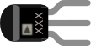
REGULATOR & TRANSISTORS
Be sure they are orientated correctly. The curved and flat sides of the silkscreen outline of the transistor on the PCB must match that of the transistor’s body.
Qty | Value | Name on PCB
1 | 7803 | REG
2 | 2N3904 | T1, T2

USB CONNECTOR
Place and solder the USB connector.

PREPARING TEENSY AND CODEC

Now we will place Teensy and the codec. Make sure orientation and placement is good before soldering.

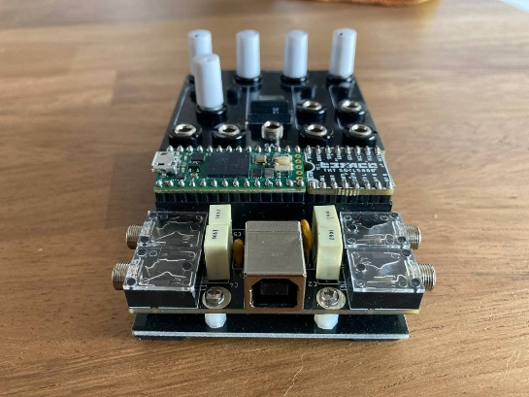

SOCKET CONNECTORS
Socket connectors will be soldered in the PCB. Place sockets on the PCB, at components side, minding the size, but do not solder them.
Qty | Size | Place on PCB
2 | 1x8 | IC11
2 | 1X14 | Long sides of footprint

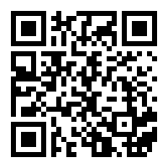
Place pin headers into the sockets, the long side of the pins that will fit in. Place Teensy (USB facing up) and codec (Befaco name facing up) boards on the pins, watch the footprint for the orientation. Do this gently. Double check they all are perfectly straight, Once all pins are in place, proceed to solder them all, both at PCB and teensy, Pushing down the teensy and codec gently.
CHECK OUR VIDEO TUTORIAL IF YOU HAVE FURTHER DOUBTS.-- >

POGO PIN HEADER
Remove the teensy and Place the Pogo pin header on the PCB, then place back the teensy pushing the pogo pins. Double check they all are perfectly straight and solder them. If not they might move and cause trouble!
Qty | Size | Place on PCB
1 | 2X5 | Between the 1x14 pins

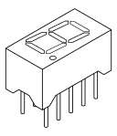

7 SEGMENT DISPLAY
Place the displays (located in ICs foam), minding that dot will face down (Segment dot) but don't solder it yet. We will wait for the front panel to be in place to solder it right.

MINI-JACKS
Place the mini-jacks on the PCB. We will place them, make sure they are flat and solder them all. You might use the panel to make sure all jacks are flat and straight.

POTENTIOMETERS
Now place the potentiometers on the PCB. Make sure they are flush against the PCB and solder them.
Qty | Type | Name on PCB
4 | Single B10k | P1, P2, P3, P5
1 | Encoder | ENC1

SD card holder
Place the SD card holder on the PCB. Do this gently, the pins could bend. Don’t solder it yet!.

FRONT PANEL
Place the plastic windows into the Display hole, from the back side of the panel. Remember to remove the protection plastic from both sides. Attach the front panel adjusting the parts one by one if necessary until it fits. At this point a pair of fine tweezers can be helpful.

Now you can proceed to place nuts and solder all components.

BOTTOM PANEL
Place the spacers facing down and screw them to the PCB and the Bottom Panel, attach the rubber circles to the bottom panel

